Jira Assignment 9

Screenshot # 1 – Create a new issue type. Make sure to take your screenshot before clicking “Add”

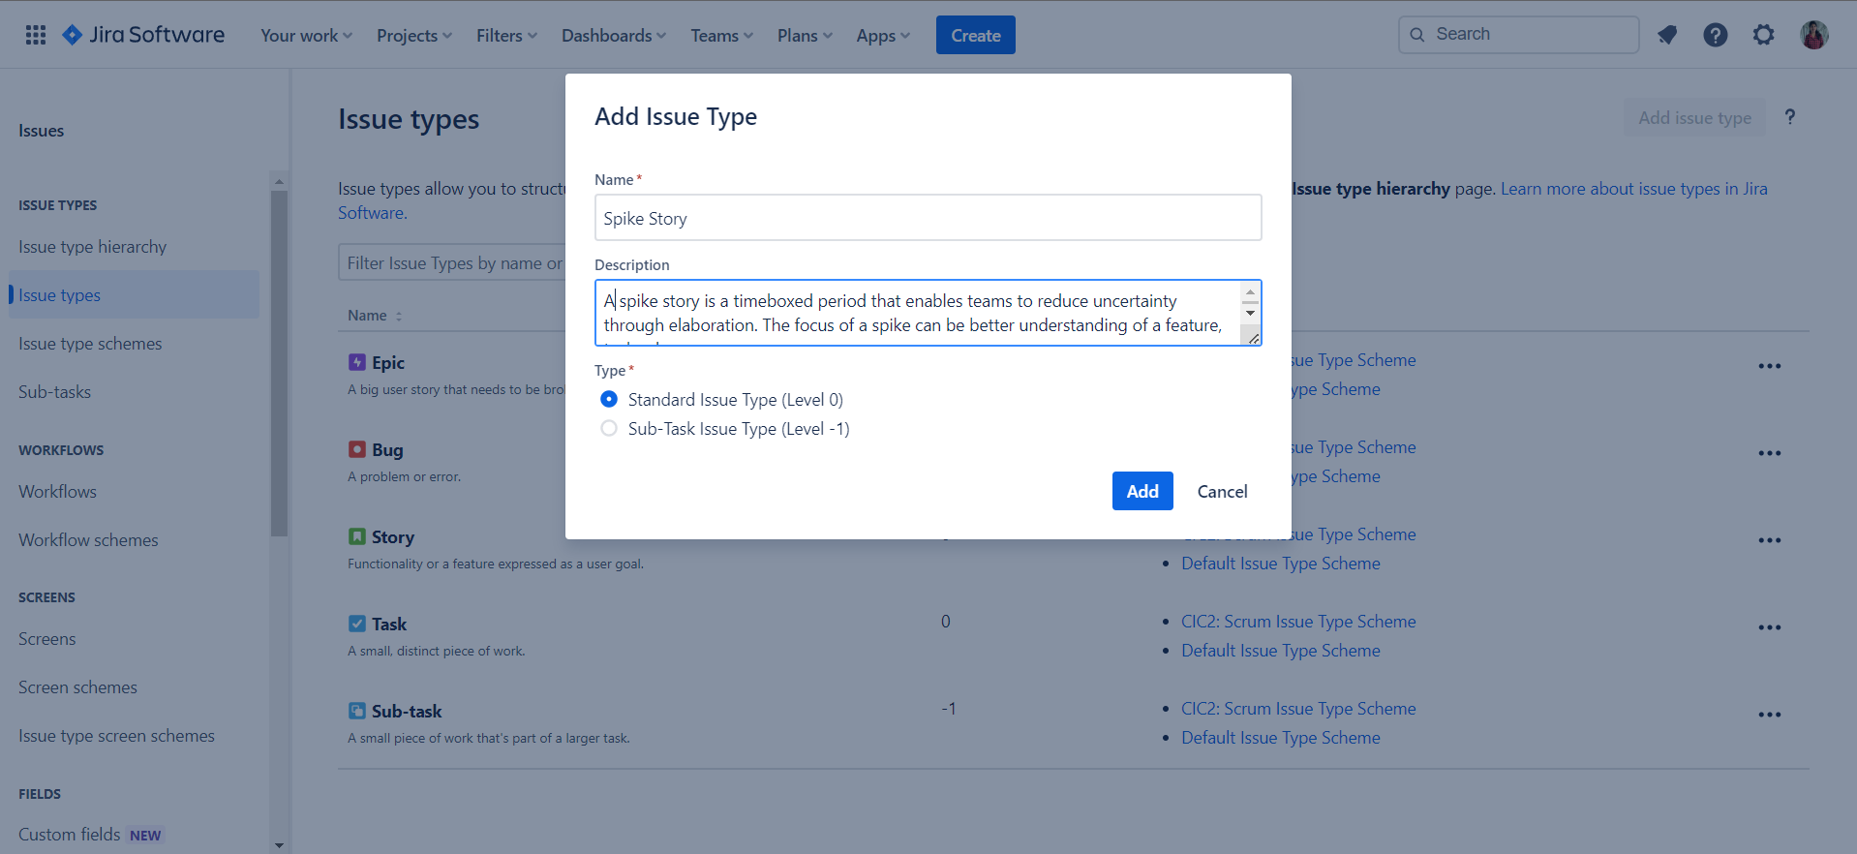

Screenshot # 2 – Associate the new issue type with your project. Instructions are shown in text.

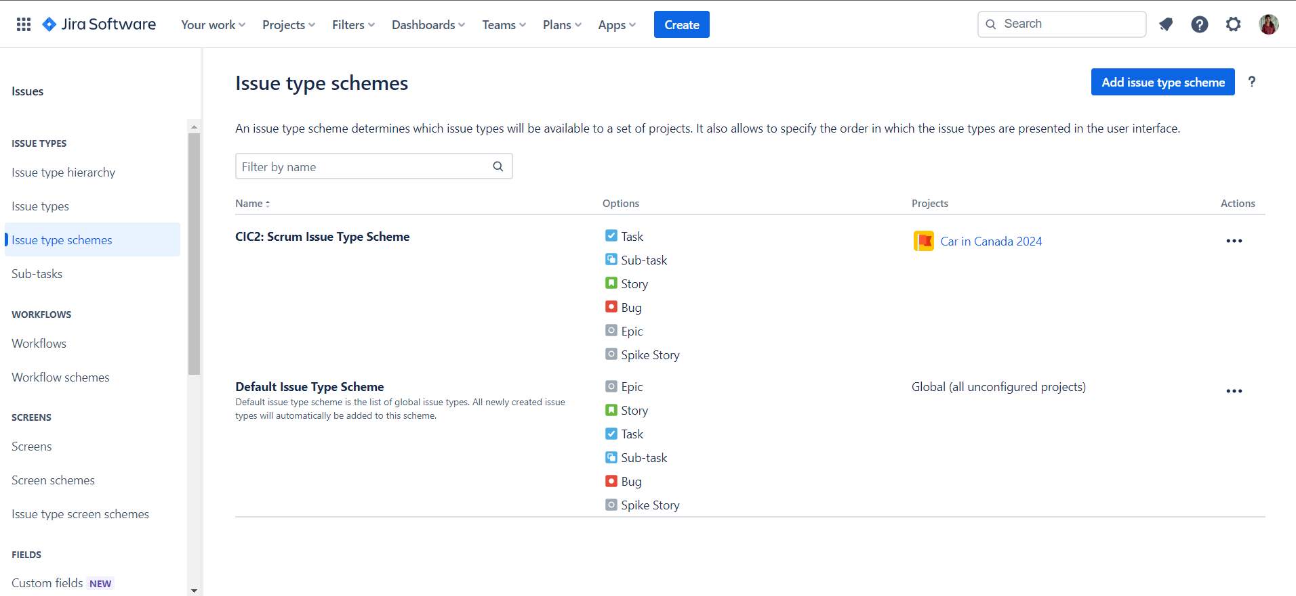

Screenshot # 3 – Create a spike story and move it to the top of your backlog.

